



جامعة ديالى

كلية التربية للعلوم الصرفة

قسم علوم الحاسبات

الدراسة الصباحية

­­

**Student Evaluation System**

**نظام تقييم الطلاب**

**المشروع مقدم الى قسم علوم الحاسوب في كلية التربية للعلوم الصرفة بجامعة ديالى كجزء من متطلبات الحصول على شهادة البكالوريوس في قسم علوم** **الحاسوب**

**أشراف :**

**ا.م.د اسم المشرف**

**من قبل الطالب :**

**محمود شمران عذيب**

**2021-2022 السنة الجامعية**

بسم الله الرحمن الرحيم

)) وقل أعملوا فسيرى الله عملكم ورسوله والمؤمنون وستردون الى عالم الغيب والشهادة فينبئكم بما كنتم تعملون ((

صدق الله العظيم

# **الإهــــــــــــــــــــداء**

• الى من اشرقت الأرض بعلمه ونور وجهه وفخر الكائنات محمد (صل الله عليه وآله وسلم)

• الى من قدموا أرواحهم فداء للوطن والعقيدة( الشهداء رحمهم الله واسكنهم فسيح جناته)

• الى من جرع الكأس فارغاً ليسقيني قطرة حب....الى من كلّت انامله ليقدم لنا لحظة سعادة ....الى من حصد الأشواك عن دربي ليمهد لي الطريق (أبي له الأحترام)

• الى من أرضعتني الحب والحنان....الى رمز الحب وبلسم الشفاء الى القلب الناصع بالبياض(أمي لها الأجلال)

• الى من هم اقرب اليه من روحي ....الى من شاركني حضن الأم ومنهم استمد عزتي (أخواني وأخواتي)

• الى من عرفت كيف اجدهم وعلموني ان لا اضيعهم (اصدقائي)

# شكر وتقدير

الحمدلله رب العالمين حمداً يليق بكماله، وأستعين به استعانة تليق بجلال ربوبيته، اشكره واثني عليه لأنجار هذا البحث وأصلي على أصدق معلم واشرف من حمل رسالة العلم والتعليم محمد (صل الله عليه وآل وسلم)

كما اشكر رئاسة قسم الحاسوب المتمثلة برئيس القسم الدكتور (الاسم)

وبالتأكيد سيبقى فضل اساتذتي عليه كبير ولا يمكن ان انساه ما حييت فمن علمهم نهلت وبتشجيعهم ودعمهم استطعت ان اخطو خطواتي في هذا الطريق .

كما لا يسعني الا ان اقدم شكري وامنياتي لكل من مد يد العون وساعدني واخص بالذكر مشرف بحثي الأستاذ (اسم المشرف) فأرجوا ان يتقبل وافر عرفاني وشكري وان يتقبل عذري على التقصير .

وشكراً لله الذي أحاطني بالصحة الطيبة ....

|  |  |  |
| --- | --- | --- |
| **Page Number** | **Subject Name** |  |
| 5 | Abstract |  |
| 6 | Chapter One |  |
| 7 | Introduction |  |
| 7 | Research Problem |  |
| 8 | Research Importance |  |
| 8 | Search Objective |  |
| 8 | System Idea |  |
| 9 | Chapter Two |  |
| 17 | Chapter Three |  |
| 22 | Chapter Four |  |
| 31 | References |  |

List Of Contents

# Abstract:

The Student Assessment System (VB .NET) project with the School Management System is a software application for the school such as public and private schools, software applications and daily activities to reduce the standards of manual work and data. In this project, we built a display of all information about the student, teacher and course materials and management of all this information (insert, update, delete, print), a software application to handle the requirements of the student, all this data is stored in a SQL database.

# Chapter One

# المقدمة

# Introduction

* 1. **Introduction: -**

The project helps you in managing Student data and teacher data with the ability to search within the tables easily and quickly. The program provides the ability to add and manage study materials and determine the time and date of each subject.

* 1. **Research Problem: -**

Many schools and educational centers in universities and schools suffer from the problem of evaluating the students’ daily grades. The professors face difficulty in recording students’ data for the purpose of giving the grade each time and they need a system that facilitates this process.

* 1. **Research Importance: -**

Solving the problem of difficulty in estimating a student's daily grades, all you have to do is enter the student's data once and then use it at a time, and with an easy and quick possibility to choose the professor and the study material.

* 1. **Search Objective: -**

The research aims to make the user’s permissions, i.e. the grades that are disabled for the student by the teacher are not presented to the other professor and this is what distinguishes the program from other educational administration program.

* 1. **System Idea: -**

The idea of the system is to make the program easy to use, away from the excessive complications that confuse users, whether a manager, teacher or employee who uses a program through a beautiful and easy graphic interface.

# Chapter Two

# قواعد بيانات

# Database

**2-1 VB.NET: -**

Visual Basic, originally called Visual Basic .NET (VB.NET), is a multi-paradigm, object-oriented programming language, implemented on.NET, Mono, and the .NET Framework. Microsoft launched VB.NET in 2002 as the successor to its original Visual Basic language, the last version of which was Visual Basic 6.0. Although the ".NET" portion of the name was dropped in 2005, this article uses "Visual Basic [.NET]" to refer to all Visual Basic languages released since 2002, in order to distinguish between them and the classic Visual Basic. Along with C# and F#, it is one of the three main languages targeting the .NET ecosystem. As of March 11, 2020, Microsoft announced that evolution of the VB.NET language has concluded. Microsoft's integrated development environment (IDE) for developing in Visual Basic is Visual Studio. Most Visual Studio editions are commercial; the only exceptions are Visual Studio Express and Visual Studio Community, which are freeware. In addition, the .NET Framework SDK includes a freeware command-line compiler called vbc.exe. Mono also includes a command-line VB.NET compiler.

Visual Basic is often used in conjunction with the Windows Forms GUI library to make desktop apps for Windows. Programming for Windows Forms with Visual Basic involves dragging and dropping controls on a form using a GUI designer and writing corresponding code for each control.

**2-2 Variables:**

A variable is nothing but a name given to a storage area that our programs can manipulate. Each variable in VB.Net has a specific type, which determines the size and layout of the variable's memory; the range of values that can be stored within that memory; and the set of operations that can be applied to the variable.

**2-3 Loops:**

There may be a situation when you need to execute a block of code several number of times. In general, statements are executed sequentially: The first statement in a function is executed first, followed by the second, and so on. Programming languages provide various control structures that allow for more complicated execution paths. A loop statement allows us to execute a statement or group of statements multiple times and following is the general form of a loop statement in most of the programming languages –

**2-4 Loop Type Description**

Do Loop It repeat the enclosed block of statements while a

Boolean condition is True or until the condition becomes

True. It could be terminated at any time with the Exit Do

Statement For...Next It repeats a group of statements a specified number of times and a loop index counts the number of loop iterations as the loop executes.

For Each...Next

It repeats a group of statements for each element in a

collection. This loop is used for accessing and

manipulating all elements in an array or a VB.Net collection.

* While... End While It executes a series of statements as long as a given
* condition is True.
* With... End with It is not exactly a looping construct. It executes a series
* of statements that repeatedly refer to a single object or
* structure.
* Nested loops You can use one or more loops inside any another
* While, For or Do loop.

**2-5 Arrays**

An array stores a fixed-size sequential collection of elements of the same type. An array is used to store a collection of data, but it is often more useful to think of an array as collection of variables of the same type. All arrays consist of contiguous memory locations. The lowest address corresponds to the first element and the highest address to the last element.

For example:

1. Dim intData(30) ' an array of 31 elements
2. Dim strData(20) As String ' an array of 21 strings
3. Dim twoDarray(10, 20) As Integer 'a two dimensional
4. array of integers
5. Dim ranges(10, 100) 'a two dimensional array

**2-6 Functions and Sub**

A procedure is a group of statements that together perform a task when called. After the procedure is executed, the control returns to the statement calling the procedure. VB.Net has two types of procedures −

1- Functions

1. Sub procedures or Subs

Note: Functions return a value, whereas Subs do not return a value

**2-7 SQL Server: -**

Structured Query Language (SQL) is a standardized programming language that is used to manage [relational databases](https://searchdatamanagement.techtarget.com/definition/relational-database) and perform various operations on the data in them. Initially created in the 1970s, SQL is regularly used not only by database administrators, but also by developers writing data integration scripts and data analysts looking to set up and run analytical queries.

The term *SQL* is pronounced *less-Kew-ell*or *sequel*.

SQL is used for the following:

* modifying database table and index structures;
* adding, updating and deleting rows of data; and
* retrieving subsets of information from within relational database management systems ([RDBMSes](https://searchdatamanagement.techtarget.com/definition/RDBMS-relational-database-management-system)) -- this information can be used for transaction processing, analytics applications and other applications that require communicating with a relational database.

SQL queries and other operations take the form of commands written as statements and are aggregated into programs that enable users to add, modify or retrieve data from database tables.

A table is the most basic unit of a database and consists of rows and columns of data. A single table holds records, and each record is stored in a row of the table. Tables are the most used type of database objects, or structures that hold or reference data in a relational database. Other types of database objects include the following:

* **Views** are logical representations of data assembled from one or more database tables.
* **Indexes** are lookup tables that help speed up database lookup functions.
* **Reports** consist of data retrieved from one or more tables, usually a subset of that data that is selected based on search criteria.

Each column in a table corresponds to a category of data -- for example, customer name or address -- while each row contains a data value for the intersecting column.

Relational databases are relational because they are composed of tables that relate to each other. For example, a SQL database used for customer service can have one table for customer names and addresses and other tables that hold information about specific purchases, product codes and customer contacts. A table used to track customer contacts usually uses a unique customer identifier called a *key* or [*primary key*](https://searchsqlserver.techtarget.com/definition/primary-key) to reference the customer's record in a separate table used to store customer data, such as name and contact information.

SQL became the de facto standard programming language for relational databases after they emerged in the late 1970s and early 1980s.

**2-8 SQL standard and proprietary extensions**

An official SQL standard was adopted by the American National Standards Institute ([ANSI](https://www.techtarget.com/searchdatacenter/definition/ANSI)) in 1986, with the International Organization for Standardization ([ISO](https://www.techtarget.com/searchdatacenter/definition/ISO)) adopting the standard in 1987. New versions of the SQL standard are published every few years, the most recent in 2016.

ISO/IEC 9075 is the ISO SQL standard developed jointly by ISO and the International Electrotechnical Commission. The standard way of referring to an ISO standard version is to use the standards organizations --ISO/IEC -- followed by the ISO standard n umber, a colon and the publication year. The current ISO standard for SQL is ISO/IEC 9075:2016.

Both proprietary and open source RDBMSes built around SQL are available for use by organizations. SQL-compliant database server products include the following:

* [Microsoft SQL Server](https://searchdatamanagement.techtarget.com/definition/SQL-Server)
* Oracle Database
* IBM [Db2](https://searchdatamanagement.techtarget.com/definition/Db2)
* SAP HANA
* SAP Adaptive Server
* Oracle [MySQL](https://searchoracle.techtarget.com/definition/MySQL)
* open source [PostgreSQL](https://whatis.techtarget.com/definition/PostgreSQL)

Some versions of SQL include proprietary extensions to the standard language for procedural programming and other functions. For example, Microsoft offers a set of extensions called [Transact-SQL](https://searchdatamanagement.techtarget.com/definition/T-SQL), while Oracle's extended version of the standard is [Procedural Language for SQL](https://searchoracle.techtarget.com/definition/PL/SQL). Commercial vendors offer proprietary extensions to differentiate their product offerings by giving customers additional features and functions. As a result, the different variants of extended SQL offered by vendors are not fully compatible with one another.

**2-9 SQL commands and syntax**

SQL is, fundamentally, a programming language designed for accessing, modifying and extracting information from relational databases. As a programming language, SQL has commands and a syntax for issuing those commands.

SQL commands are divided into several different types, including the following:

* **Data Definition Language (**[**DDL**](https://whatis.techtarget.com/definition/Data-Definition-Language-DDL)**)**commands are also called *data definition commands* because they are used to define data tables.
* **Data Manipulation Language (DML)**commands are used to manipulate data in existing tables by adding, changing or removing data. Unlike DDL commands that define how data is stored, DML commands operate in the tables defined with DDL commands.
* **Data Query Language** consists of just one command, SELECT, used to get specific data from tables. This command is sometimes grouped with the DML commands.
* **Data Control Language** commands are used to grant or revoke user access privileges.
* **Transaction Control Language** commands are used to change the state of some data -- for example, to COMMIT transaction changes or to ROLLBACK transaction changes.

SQL syntax, the set of rules for how SQL statements are written and formatted, is similar to other programming languages. Some components of SQL syntax include the following:

* SQL statements start with a SQL command and end with a semicolon (**;**), for example:

SELECT * FROM customers;

This SELECT statement extracts all of the contents of a table called customers.

# 

# Chapter Three

# التصميم

# Design

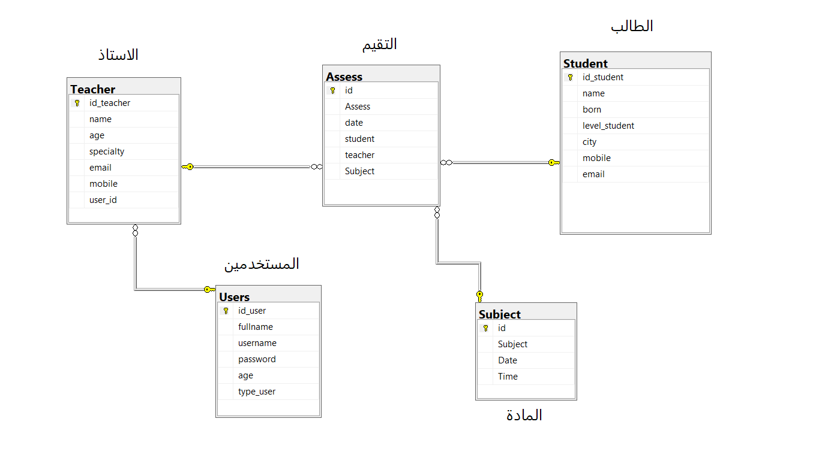

3-1. Diagram Database

**Users:**

It is the table responsible for storing user data and managing program permissions, in addition to the login process.

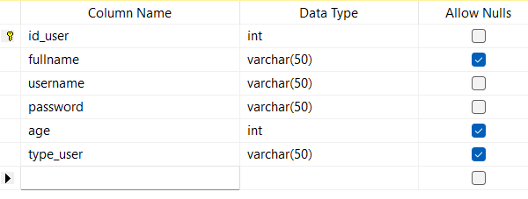

**Teacher:**

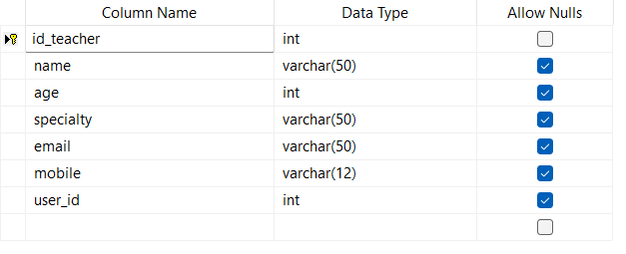

Table Date

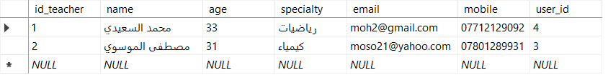

**Subject:**

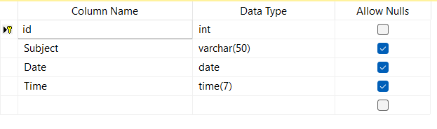

Table Date

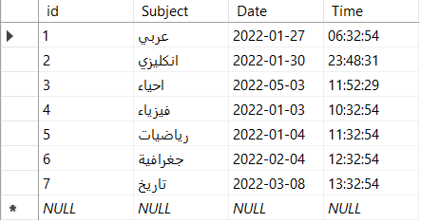

**Student:**

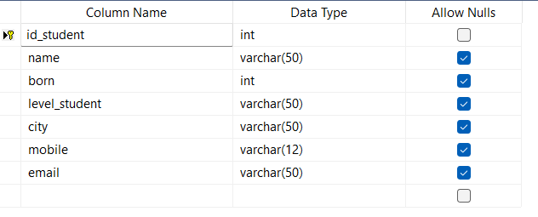

Table Date

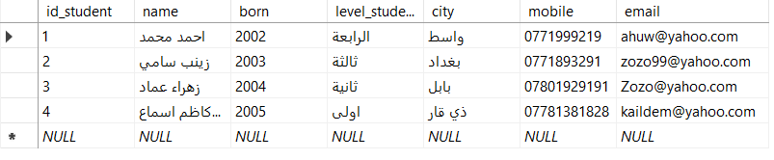

**Assess:**

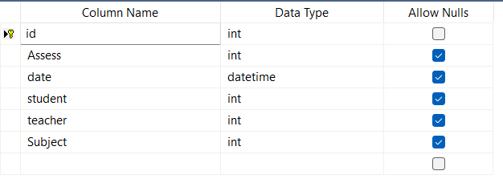

Table Date

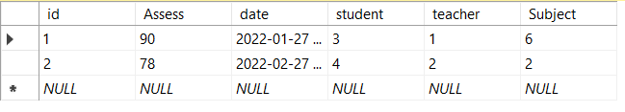

# Chapter Four

# التنفيذ

# implementation

**Splash Screen:**

welcome window: It is the first window that appears when the program is running. It contains a Progress Bar, which is a counter that increases automatically when the counter value becomes 100. The window closes and the next window opens, which is the login window.

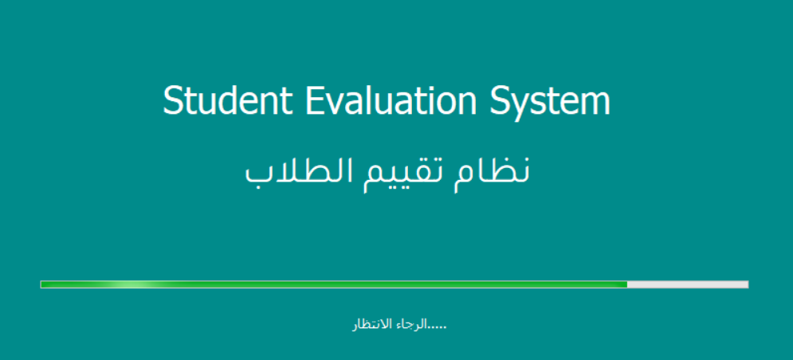

**Login Screen:**

It is the second window that appears in the project immediately after the login process. This window cannot be bypassed unless after filling in the username and password data correctly.

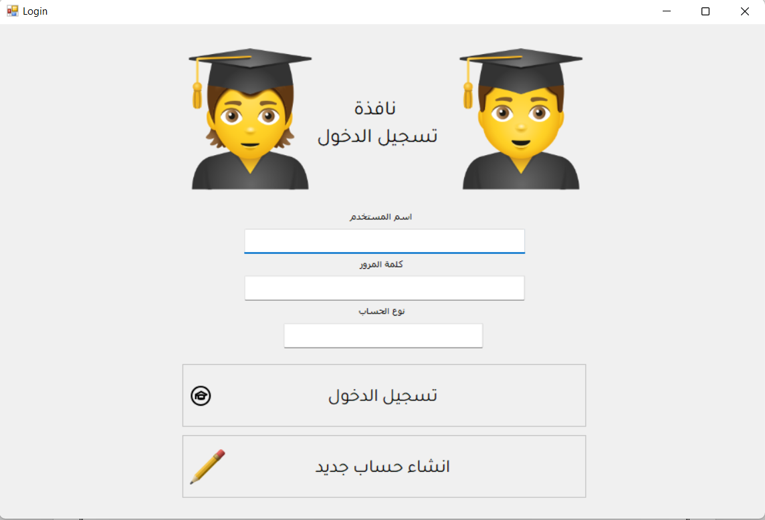

**Registry Screen:**

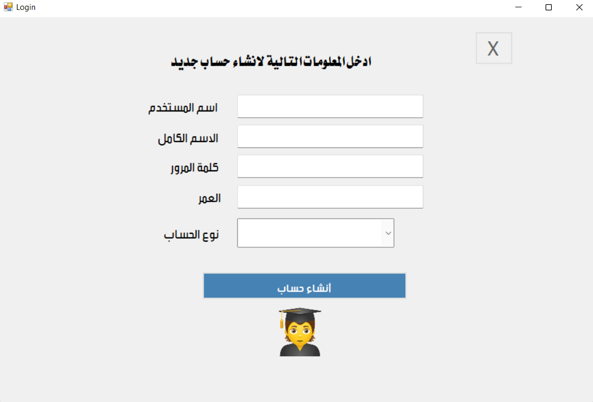

**Main Menu:**

It is considered one of the most important interfaces in the program because it shows all the windows in the project and the user can choose the desired window very easily.

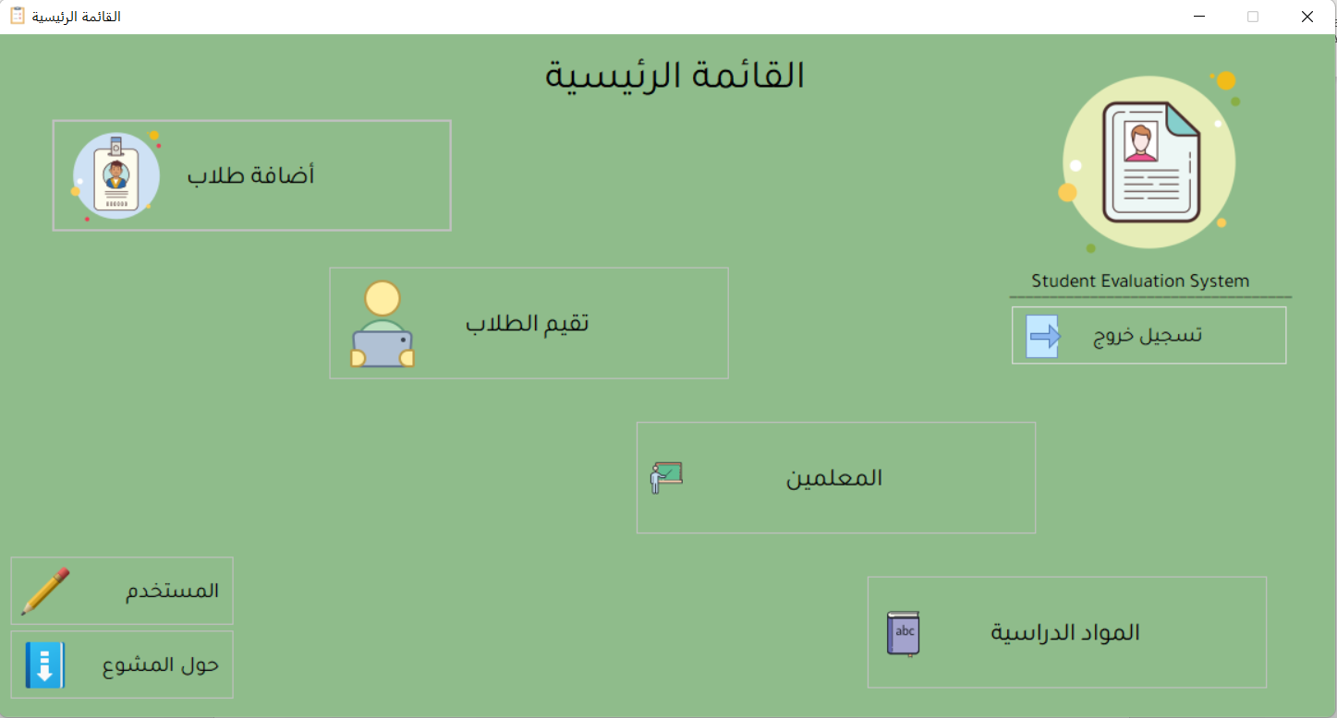

**Student:**

Manage student data by adding data, updating data, deleting data, and displaying data such as student number, name, birth, stage, housing, phone and e-mail.

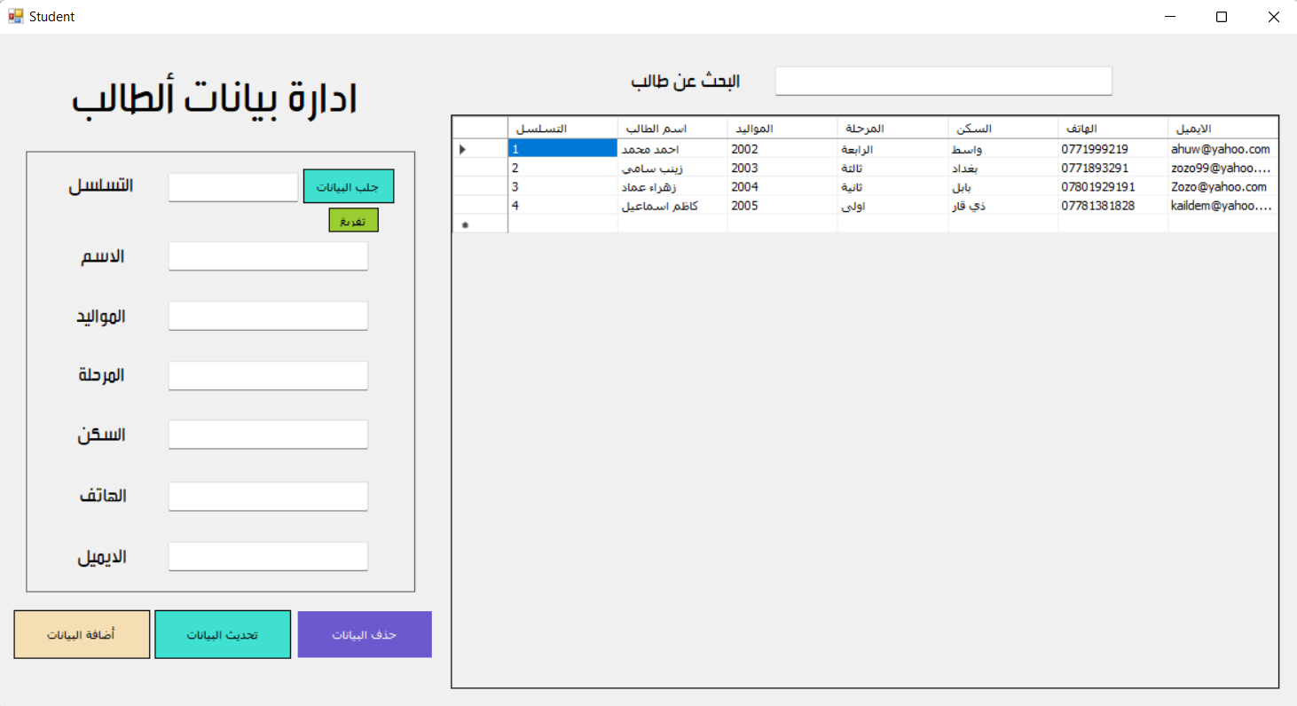

**Teacher:**

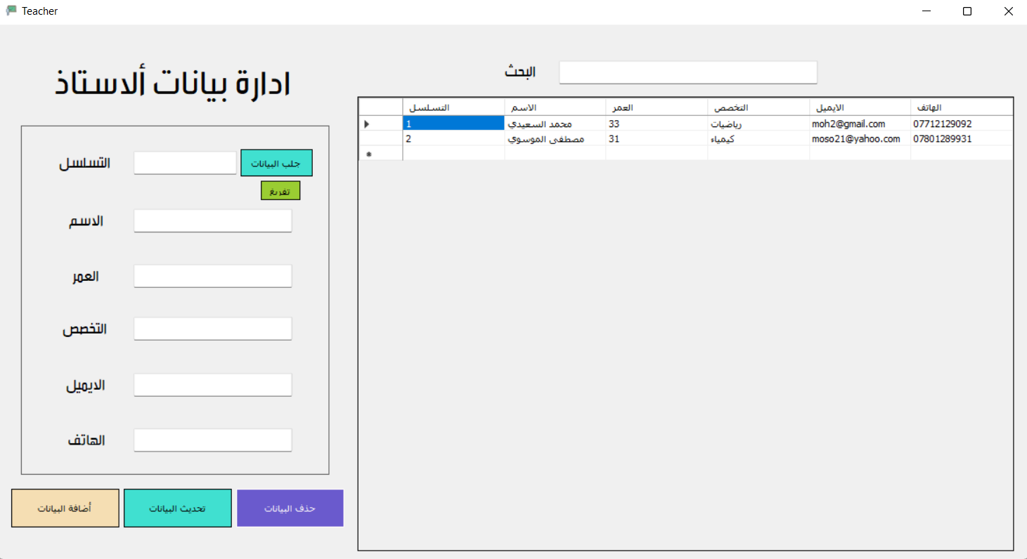

**Subject:**

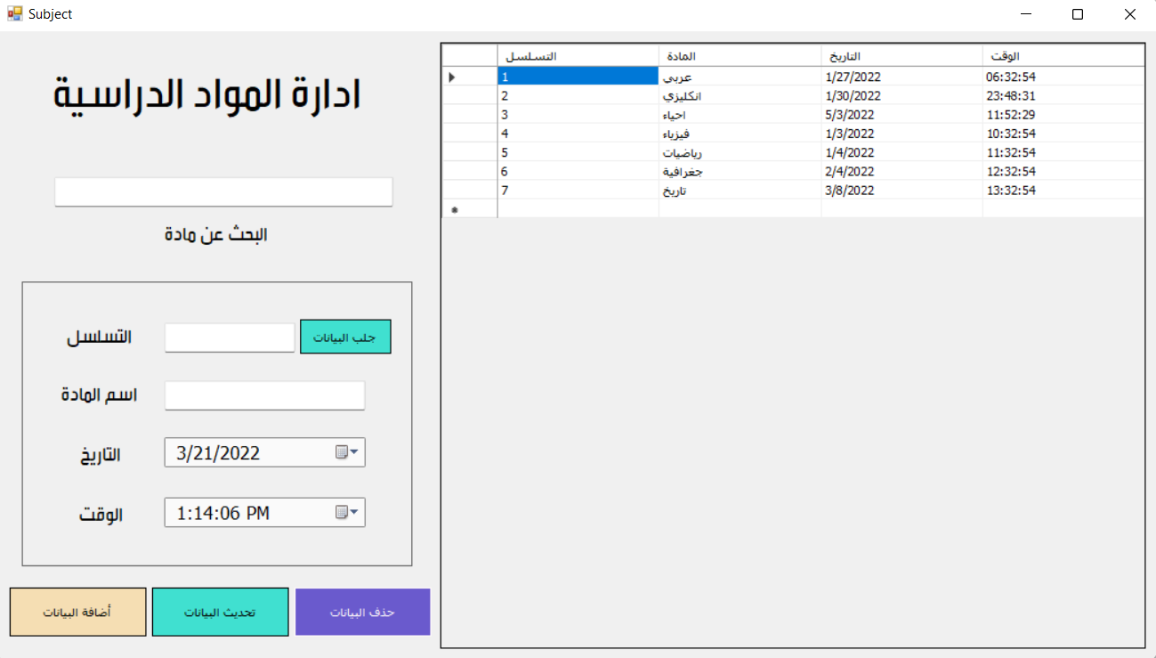

**Assess:**

The student evaluation window is the main window in the system. Data is stored in the evaluation table and data such as student number, teacher number, subject number, and evaluation degree, with automatic recording of the evaluation date.

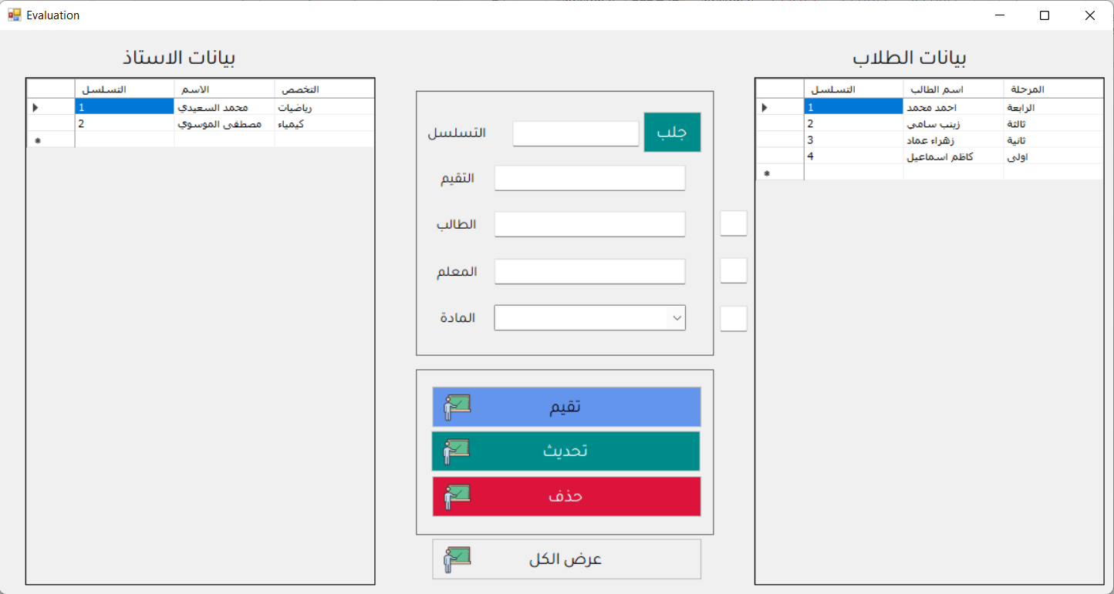

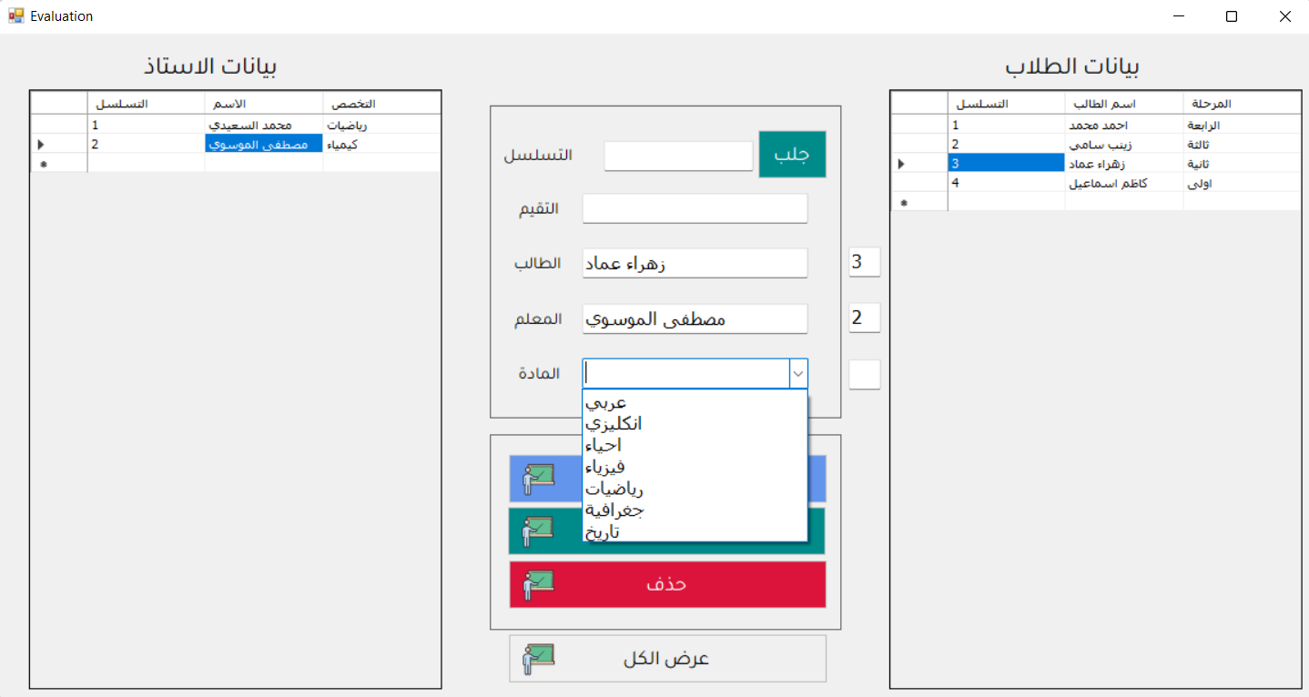

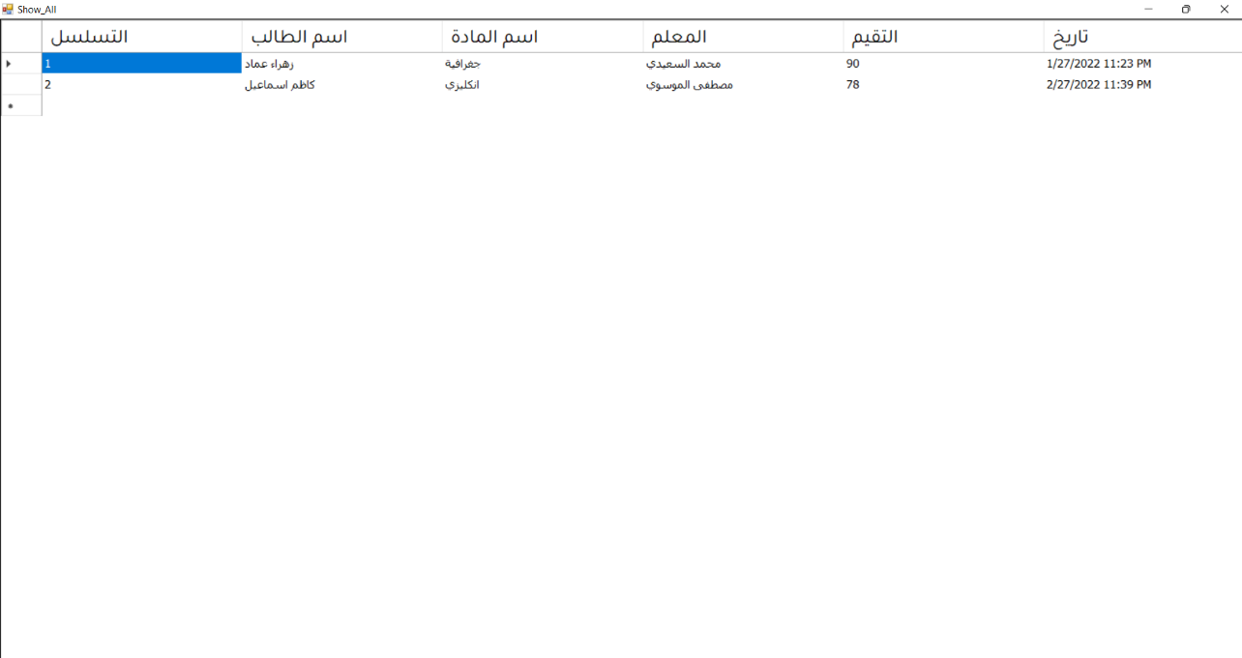**Show All info Degrees Student:**

**User Allow:**

User permissions are important things in the system to protect and allocate specific sections or parts of the program so that the user can access it. For example, the system administrator can access any window, but the teacher can access students and evaluate the student only.

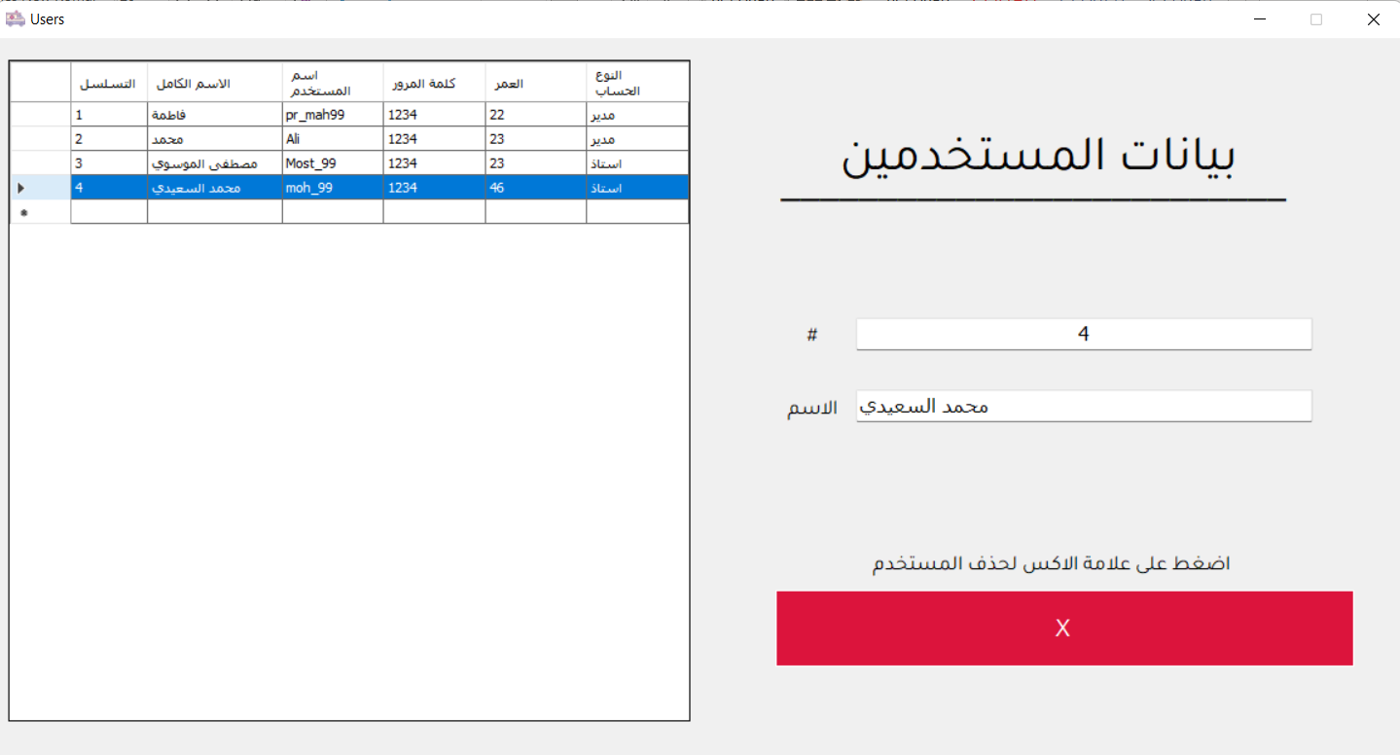

**About Project:**

Here in this window, the project data appears, such as the name of the project, the name of the programmer’s students, and the name of the doctor supervising the project.

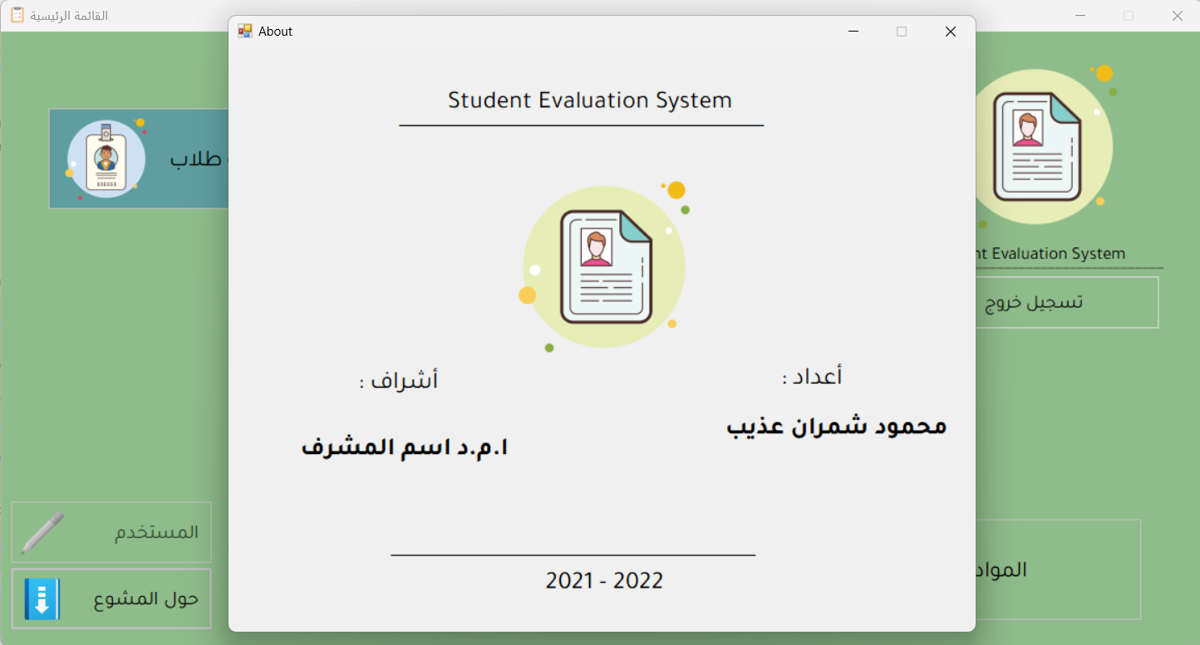

# Chapter Five

Conclusions and Recommendations

* 1. **Conclusions:**

It is a system that can manage students and teachers, evaluate students, and display data easily.

This system can be used to manage the school. You can add a payroll and allocation section, program its management, add data, update and delete information, and a special section for expenses can be added and a window to calculate the grand total for each row of important data and print it.

Further system development could include programming the mobile version of application for Android and iOS operating systems.

It is possible to upload a database on hosting and follow up on the status of the school from anywhere in the world with ease.

* 1. **Recommendations:**

We recommend installing this project in all public and private schools to be easily managed and to monitor all operations, salaries, expenses, student data and others.

# **References:**

1. **Amichai-Hamburger, Y. (2007). Personality, individual differences and Internet use. In A. Joinson,**

K. Y. A. McKenna, T. Postmes & U. D. Reips (Eds), Oxford handbook of Internet psychology (pp. 187–204).

Oxford: Oxford University Press.

1. **Anderson, R. & Dexter, S. (2005). School technology leadership: an empirical investigation of prevalence**

and effect. Educational Administration Quarterly, 41, 1, 49–82.

1. **Avidov-Unger, O. & Eshet-Alkalai, Y. (2011). Teachers in a world of change: teachers’ knowledge and**

attitudes towards the implementation of innovative technologies in schools. Interdisciplinary Journal of

e-Learning and Learning Objects, 7, 291–303.

1. **Barak, A. & Suler, J. (2008). Reflections on the psychology and social science of cyberspace. In A. Barak**

(Ed.), Psychological aspects of cyberspace: theory, research, applications (pp. 1–12). Cambridge: Cambridge

University Press.

1. **Blau, I. & Barak, A. (2012). How do personality, synchronous media, and discussion topic affect social**

participation? Educational Technology & Society, 15, 2, 12–24